The primal IP problem is:
$$\begin{matrix}max & z=9x_{1}+12x_{2} \\ s.t. & 3x_{1}+ x_{2}≥4 \\ & x_{1}+ 2x_{2}≥6 \\ & x_{1}, { x}_{2}≥0, integer\end{matrix}$$
Release the integer constraints:
$$\begin{matrix}max & z=9x_{1}+12x_{2} \\ s.t. & 3x_{1}+ x_{2}≥4 \\ & x_{1}+ 2x_{2}≥6 \\ & x_{1}, x_{2}≥0\end{matrix}$$
Firstly, we use 2-Phase Simplex Tableau to get a feasible solution:
Phase 1:
Add surplus variables and artificial variables:
$$\begin{matrix}min & s_{1}+s_{2} \\ s.t. & 3x_{1}+x_{2}-e_{1}+s_{1}=4 \\ & x_{1}+2x_{2}-e_{2}+s_{2}=6 \\ & x_{1}, x_{2}, e_{1},e_{2},s_{1},s_{2}≥0\end{matrix}$$
 | $$x_{1}$$ | $$x_{2}$$ | $$e_{1}$$ | $$e_{2}$$ | $$s_{1}$$ | $$s_{2}$$ | RHS
Row 0 | $$0$$ | $$0$$ | $$0$$ | $$0$$ | $$-1$$ | $$-1$$ | $$0$$
$$s_{1}$$ | $$3$$ | $$1$$ | $$-1$$ | $$0$$ | $$1$$ | $$0$$ | $$4$$
$$s_{2}$$ | $$1$$ | $$2$$ | $$0$$ | $$-1$$ | $$0$$ | $$1$$ | $$6$$
After Initialization:
 | $$x_{1}$$ | $$x_{2}$$ | $$e_{1}$$ | $$e_{2}$$ | $$s_{1}$$ | $$s_{2}$$ | RHS
Row 0 | $$4$$ | $$3$$ | $$-1$$ | $$-1$$ | $$0$$ | $$0$$ | $$10$$
$$s_{1}$$ | $$3$$ | $$1$$ | $$-1$$ | $$0$$ | $$1$$ | $$0$$ | $$4$$
$$s_{2}$$ | $$1$$ | $$2$$ | $$0$$ | $$-1$$ | $$0$$ | $$1$$ | $$6$$
After Iteration 1:
 | $$x_{1}$$ | $$x_{2}$$ | $$e_{1}$$ | $$e_{2}$$ | $$s_{1}$$ | $$s_{2}$$ | RHS
Row 0 | $$0$$ | $$5/3$$ | $$1/3$$ | $$-1$$ | $$-4/3$$ | $$0$$ | $$14/3$$
$$x_{1}$$ | $$1$$ | $$1/3$$ | $$-1/3$$ | $$0$$ | $$1/3$$ | $$0$$ | $$4/3$$
$$s_{2}$$ | $$0$$ | $$5/3$$ | $$1/3$$ | $$-1$$ | $$-1/3$$ | $$1$$ | $$14/3$$
After Iteration 2:
 | $$x_{1}$$ | $$x_{2}$$ | $$e_{1}$$ | $$e_{2}$$ | $$s_{1}$$ | $$s_{2}$$ | RHS
Row 0 | $$0$$ | $$0$$ | $$0$$ | $$0$$ | $$-1$$ | $$-1$$ | $$0$$
$$x_{1}$$ | $$1$$ | $$0$$ | $$-2/5$$ | $$1/5$$ | $$2/5$$ | $$-1/5$$ | $$2/5$$
$$x_{2}$$ | $$0$$ | $$1$$ | $$1/5$$ | $$-3/5$$ | $$-1/5$$ | $$3/5$$ | $$14/5$$
Phase 2:
 | $$x_{1}$$ | $$x_{2}$$ | $$e_{1}$$ | $$e_{2}$$ | RHS
Row 0 | $$-9$$ | $$-12$$ | $$0$$ | $$0$$ | $$0$$
$$x_{1}$$ | $$1$$ | $$0$$ | $$-2/5$$ | $$1/5$$ | $$2/5$$
$$x_{2}$$ | $$0$$ | $$1$$ | $$1/5$$ | $$-3/5$$ | $$14/5$$
After Initialization:
 | $$x_{1}$$ | $$x_{2}$$ | $$e_{1}$$ | $$e_{2}$$ | RHS
Row 0 | $$0$$ | $$0$$ | $$-6/5$$ | $$-27/5$$ | $$186/5$$
$$x_{1}$$ | $$1$$ | $$0$$ | $$-2/5$$ | $$1/5$$ | $$2/5$$
$$x_{2}$$ | $$0$$ | $$1$$ | $$1/5$$ | $$-3/5$$ | $$14/5$$
So we get the optimal solution for the released problem:
$$\begin{matrix}x_{1}=0.4 \\ x_{2}=2.8\end{matrix}$$
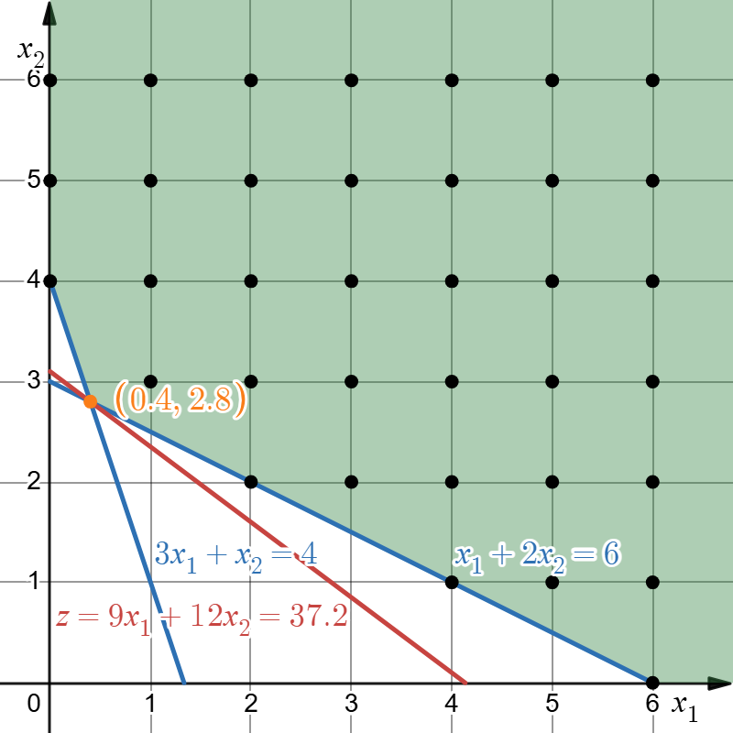
Then, we can start using cutting plane method.
$$\begin{matrix}x_{1} -0.4e_{1}+0.2e_{2}=0.4 \\ x_{2}+0.2e_{1}-0.6e_{2}=2.8\end{matrix}$$
We choose the second constraint, and round down the LHS:
$$x_{2}-e_{2}≤2.8$$
Then round down the RHS:
$$x_{2}-e_{2}≤2$$
Then, we add this new inequality into the constraints in the LP relaxation’s optimal tableu:
$$\begin{matrix}x_{1} -0.4e_{1}+0.2e_{2}=0.4 \\ x_{2}+0.2e_{1}-0.6e_{2}=2.8 \\ x_{2} - e_{2}≤2 \end{matrix}$$
We can solve from these expressions that the new constraint is:
$$x_{1}+x_{2}≥4$$
Then we add this constraint into the tableau:
 | $$x_{1}$$ | $$x_{2}$$ | $$e_{1}$$ | $$e_{2}$$ | $$e_{3}$$ | RHS
Row 0 | $$0$$ | $$0$$ | $$-6/5$$ | $$-27/5$$ | $$0$$ | $$186/5$$
$$x_{1}$$ | $$1$$ | $$0$$ | $$-2/5$$ | $$1/5$$ | $$0$$ | $$2/5$$
$$x_{2}$$ | $$0$$ | $$1$$ | $$1/5$$ | $$-3/5$$ | $$0$$ | $$14/5$$
$$e_{3}$$ | $$1$$ | $$1$$ | $$0$$ | $$0$$ | $$-1$$ | $$4$$
Initialize it:
 | $$x_{1}$$ | $$x_{2}$$ | $$e_{1}$$ | $$e_{2}$$ | $$e_{3}$$ | RHS
Row 0 | $$0$$ | $$0$$ | $$-6/5$$ | $$-27/5$$ | $$0$$ | $$186/5$$
$$x_{1}$$ | $$1$$ | $$0$$ | $$-2/5$$ | $$1/5$$ | $$0$$ | $$2/5$$
$$x_{2}$$ | $$0$$ | $$1$$ | $$1/5$$ | $$-3/5$$ | $$0$$ | $$14/5$$
$$e_{3}$$ | $$0$$ | $$0$$ | $$-1/5$$ | $$-2/5$$ | $$1$$ | $$-4/5$$
Using Dual Simplex, we can get:
Row 0 | $$0$$ | $$0$$ | $$0$$ | $$-3$$ | $$-6$$ | $$42$$
$$x_{1}$$ | $$1$$ | $$0$$ | $$0$$ | $$1$$ | $$-2$$ | $$2$$
$$x_{2}$$ | $$0$$ | $$1$$ | $$0$$ | $$-1$$ | $$1$$ | $$2$$
$$e_{1}$$ | $$0$$ | $$0$$ | $$1$$ | $$2$$ | $$-5$$ | $$4$$
So the optimal solution for this restricted LP problem is: $x_{1}=2, x_{2}=2$
So the optimal solution for the primal IP problem is:
$$\begin{matrix}x_{1}=2 \\ x_{2}=2\end{matrix}$$
The minimum objective function value is $42$.